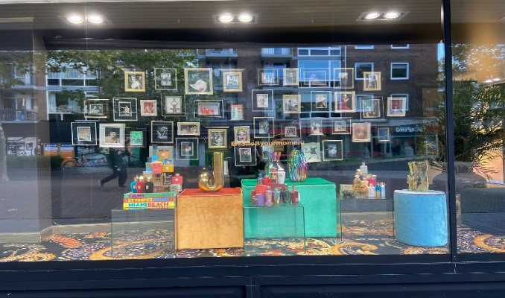Final Programming Project s2615444  
Synopsis

My shop window is pictured down below. It is showing a lot of picture frames with random pictures in it. Below the picture frames there are colorful items that take your attention while walking past the store. The location of the store is in the city center of Enschede on the Zuiderhagen. The returning elements are the picture frames and having clutter near them.

Usage and interactions  
The program allows you to change the interior of the store window to an extent to make it fit your aesthetic. Itemized list:

* Picture frame will have 2interactions: pressing the spacebar will make the color change and pressing Q, W, E, R, T, Y, U, I, O or P will make a picture in the frame change.
* Clutter will be divided into books and a vase. You can click the books to change them, and you can click the vase to make flowers appear. You can press on the flower to make it disappear and you can click on the cube below the books to reset them.
* In front of the store there will be people walking. On the right there is a woman standing that you can click on. When clicked on she starts walking as well.

Architecture  
Itemized list:   
Most important methods:

* move() – makes it possible to move so it allows animation. Is used in 3 classes.
* ChangeColor() – makes the color of the frame change.
* ChangePicture() – makes the picture in the picture frame change.
* mousePressed() – in combination with Booleans allows methods from other classes that are called here to instigate.
* keyPressed() – allows ChangeColor() and PictureChange() to function by calling them from their classes.
* activateWalker() – allows move() to be instigated in the WalkerL class.

Classes used:

* Frame – controls the actual framing of the picture frame.
* Picture – is the inside of the picture frame.
* Book (Clutter) – book with its own interaction.
* Cubes (Clutter) – there for decoration purposes and to hold the vase.
* Ball – oval shape that bounces up and down for aesthetic purposes.
* WalkerL – people that walk from the right to the left.
* WalkerR – people that walk from the left to the right.

|  |
| --- |
| Book |
| Book() |
| display() |
| TitleChange() |
| Boolean changeText |
| Boolean changeTitle |

|  |
| --- |
| Cube |
| Cube() |
| display() |
| Flowergrowth() |
| Boolean Grown |

|  |
| --- |
| Frame |
| Frame() |
| display() |
| ChangeColor() |

|  |
| --- |
| Shop_window |
| setup() |
| draw() |
| mousePressed() |
| keyPressed() |

|  |
| --- |
| Oval |
| Oval() |
| display() |
| move() |

|  |
| --- |
| Pictures |
| Pictures() |
| display() |
| PictureChange() |
| Boolean qPressed |
| Boolean ePressed |
| Boolean tPressed |
| Boolean uPressed |
| Boolean oPressed |

|  |
| --- |
| WalkerL |
| WalkerL() |
| display() |
| activateWalker() |
| move() |
| Boolean walkerActive |

|  |
| --- |
| WalkerR |
| WalkerR() |
| display() |
| move() |
| Boolean borderReached |